DEVELOPMENT BASED ENVIRONMENTAL MONITORING

Phase 3 project document

TEAM MEMBERS:

RITHIGA. A

SANKARI.V

BARANIKA.G

SUBASRI.K

Introduction:

IoT in environmental technology allows us to collect real-time data on various environmental parameters, such as air quality, water quality, and soil moisture, among others, leading to actionable insights.  One of the most promising technologies that can help achieve this goal is the Internet of Things (IoT).

Importance and loading process of dataset:

1. It is therefore important to have sufficiently optimized the dataset to ensure that the dataset can be successfully loaded into available system memory. The size of the dataset is affected by both the number of fields and the number of records in the dataset.
2. Crucial for effective data analytics is the accessibility of data that has been collected and depending on which data loading method you use, there are opportunities to not only significantly speed up your time to analytics and insights but also to dramatically improve overall data quality and accuracy.
3. The major components of the environmental Monitoring process include: monitoring design, quality assurance, data management, data analysis, research and development in support of data collection and .

Challenges of environmental monitoring:

The challenges in environmental monitoring are multiple – improving sample throughput; handling a variety of gaseous, liquid and solid matrices; reliably sampling a wide range of VOCs and SVOCs.

1. This will be my first time at these shows, so I’m looking forward to going along and meeting the major players in the UK environmental scene, as well as seeing the latest developments in monitoring technology to tackle emerging challenges.

**Fence-line monitoring for refineries**

1. Of course, air sampling and analysis has long been the bread-and-butter of environmental monitoring applications, but things are evolving quickly. Use of sorbent tubes to sample the air around refinery fence-lines has been mandated in the USA for a couple of years now under CFR 40.
2. As experts in the field of air-monitoring, Markes International naturally offers a complete package of equipment for monitoring fence-lines for benzene and other target compounds – pop along to Markes’ booth and we can talk about your requirements

**Stack emissions monitoring**

However, in the years since CEN/TS 13649 was released, thermal desorption (TD) has become far more popular than solvent extraction for analysis of airborne VOCs. In recognition of this, a 2014 update to the method offers TD as an alternative, bringing it into line with other national and international standard methods for VOC analysis.

Program of environmental monitoring:

import random

import time

class EnvironmentalMonitor:

def _init_(self):

self.temperature = 0

self.humidity = 0

def read_sensor_data(self):

# Simulate sensor data (replace this with real sensor readings)

self.temperature = random.uniform(20, 30)

self.humidity = random.uniform(40, 60)

def display_data(self):

print(f"Temperature: {self.temperature}°C | Humidity: {self.humidity}%")

def main():

monitor = EnvironmentalMonitor()

while True:

monitor.read_sensor_data()

monitor.display_data()

time.sleep(5) # Adjust the time interval based on your needs

if _name_ == "_main_":

main();

Application of Environmental monitoring:

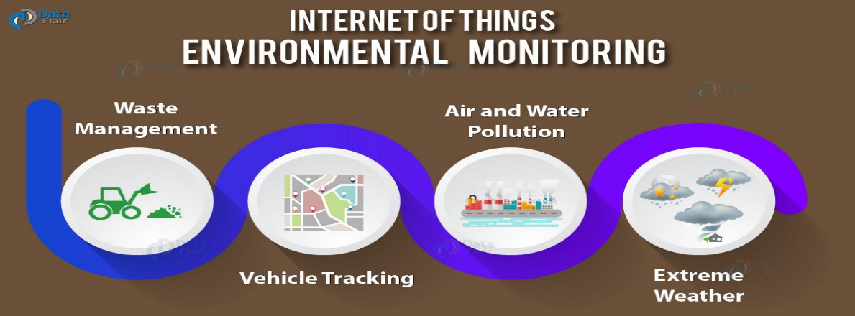

Internet of things Environmental monitoring:

IoT in environmental monitoring is a network of interconnected devices and wireless [IoT sensors](https://infisim.com/blog/iot-sensors-and-what-they-do) that collect and transmit environmental data to a central database or cloud platform. The devices, such as wireless sensors and cameras, are equipped with various environmental monitoring capabilities, such as temperature, humidity, air quality, and water quality. This is of great use to farmers using [IoT in agriculture](https://infisim.com/m2m-by-industry/iot-in-agriculture) or [precision farming](https://infisim.com/blog/iot-in-precision-farming).

Waste Management:

The aim of waste management is to reduce the dangerous effects of such waste on the environment and human health. A big part of waste management deals with municipal solid waste, which is created by industrial, commercial, and household activity.

Waste management practices are not uniform among countries ([developed](https://en.wikipedia.org/wiki/Developed_nation) and [developing nations](https://en.wikipedia.org/wiki/Developing_nation)); regions ([urban](https://en.wikipedia.org/wiki/Urban_area) and [rural areas](https://en.wikipedia.org/wiki/Rural_area)), and [residential](https://en.wikipedia.org/wiki/Residential_area) and [industrial](https://en.wikipedia.org/wiki/Industrial_sector) sectors can all take different approaches.

Waste can be [solid](https://en.wikipedia.org/wiki/Solid), [liquid](https://en.wikipedia.org/wiki/Liquid), or [gases](https://en.wikipedia.org/wiki/Gaseous) and each type has different methods of disposal and management. Waste management deals with all types of waste, including industrial, [biological](https://en.wikipedia.org/wiki/Biological), household, municipal, organic, [biomedical](https://en.wikipedia.org/wiki/Biomedical), [radioactive wastes.](https://en.wikipedia.org/wiki/Radioactive_waste) In some cases, waste can pose a threat to human health.[[2]](https://en.wikipedia.org/wiki/Waste_management#cite_note-JWM-2) Health issues are associated with the entire process of waste management.

Vehicle Tracking

Several types of vehicle tracking devices exist. Typically they are classified as "passive" and "active". "Passive" devices store GPS location, speed, heading and sometimes a trigger event such as key on/off, door open/closed. Once the vehicle returns to a predetermined point, the device is removed and the data downloaded to a computer for evaluation. Passive systems include auto download type that transfer data via wireless download. "Active" devices also collect the same information but usually transmit the data in near-real-time via [cellular](https://en.wikipedia.org/wiki/Cellular_network) or [satellite networks](https://en.wikipedia.org/wiki/Satellite_network) to a computer or data center for evaluation.

Historically, vehicle tracking has been accomplished by installing a box into the vehicle, either self-powered with a battery or wired into the vehicle's power system. For detailed vehicle locating and tracking this is still the predominant method;

 These systems also offer tracking of calls, texts, web use and generally provide a wider range of options.

Air and Water Pollution:

Air pollution has been the highlight of all major international level meetings, air is something we all share and cherish. The presence of breathable air is very important for leading a healthy life, the recent levels of air pollution witnessed around the world has been of serious concern for all the people, different environmentalists like Greta Thunberg, etc have raised their voices forcing the governments to change their policies regarding pollution

the air pollution because they have to be at the core of the polluted air. Air pollution directly affects the health of humans and animals alike. The air humans and animals breathe is directed to the lungs and as such the pollutants present in the air directly get into the lungs and can lead to lung cancers. In the case of animals, several cases of deaths related to air pollution have been witnessed in different parts of the world. Also, birds have been severely affected by

Water pollution has also been of extreme concern for leaders and people around the globe. Several efforts are being implemented to reduce the water pollution levels to the minimum. It is found that the most polluted water bodies are those which are nearer to the residential or the commercial areas.

Air and Water pollution both are very harmful to human existence on this planet. Air and water are the most precious natural resources which are present in abundance but we misuse and abuse them. The pollution in any of these has a serious effect on the lives of humans and animals alike. Air and water pollution if abused to the maximum level can’t be turned back on immediately, several diseases and disorders previously unknown to humans have been identified as a consequence of air and water getting polluted with poisonous substances which are released from chemical and other such [environment](https://www.vedantu.com/biology/environment) degrading industries

Extreme Weather:

**Extreme weather** includes unexpected, unusual, [severe](https://en.wikipedia.org/wiki/Severe_weather), or unseasonal [weather](https://en.wikipedia.org/wiki/Weather); weather at the extremes of the historical distribution—the range that has been seen in the past.[[1]](https://en.wikipedia.org/wiki/Extreme_weather#cite_note-1)[[2]](https://en.wikipedia.org/wiki/Extreme_weather#cite_note-:8-2) Extreme events are based on a location's recorded weather history.

Extreme weather describes unusual weather events that are at the extremes of the historical distribution for a given area. The [IPCC Sixth Assessment Report](https://en.wikipedia.org/wiki/IPCC_Sixth_Assessment_Report) defines an extreme weather event as follows: "An event that is rare at a particular place and time of year. Definitions of 'rare' vary, but an extreme weather event would normally be as rare as or rarer than the 10th or 90th percentile of a probability density function estimated from observations.

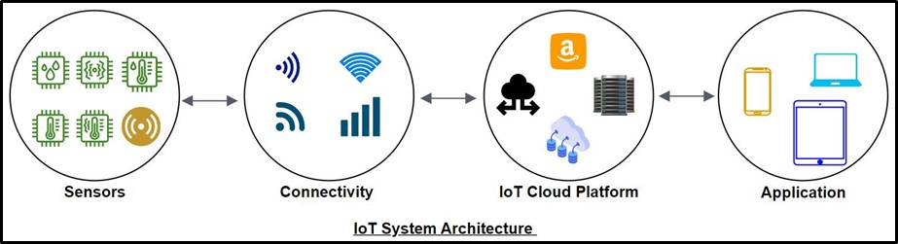

Conclusion:

Conclusion The Internet is an effective medium of communication with audience. It attracts, retains and manages the customers and engages them in a long-term relationship. It is the newest form of technological advancement used for direct communication with customers.

Conclusion. The Internet is a real tool to help learn, connect, design, develop, and entertain in every sector. We are saving so many hours by doing work from home, getting connected through video conferences, and sharing documents online